## Loan Management System Defect Report

### Summary

This report details all the defects identified during testing of the Maogma Loan Management System, actions taken by the QA Tester, and Steps to reproduce.

* Environment Information

url link: localhost:3000

username: jane_doe

Password: 1234

* Emailjs Information
* 'Service id :service_6ya7ug8',
* Template id: template_42j8dsc',
* 'User id: psyh2lUD06KfINrVj'

### Module: Loan Management - TC_LM

##### TC_LM_006: Application does not list existing loan transactions in the system

Application does not list existing loan transactions in the system as per below screenshot. As a user, I need the ability to view all existing loan transactions in the system

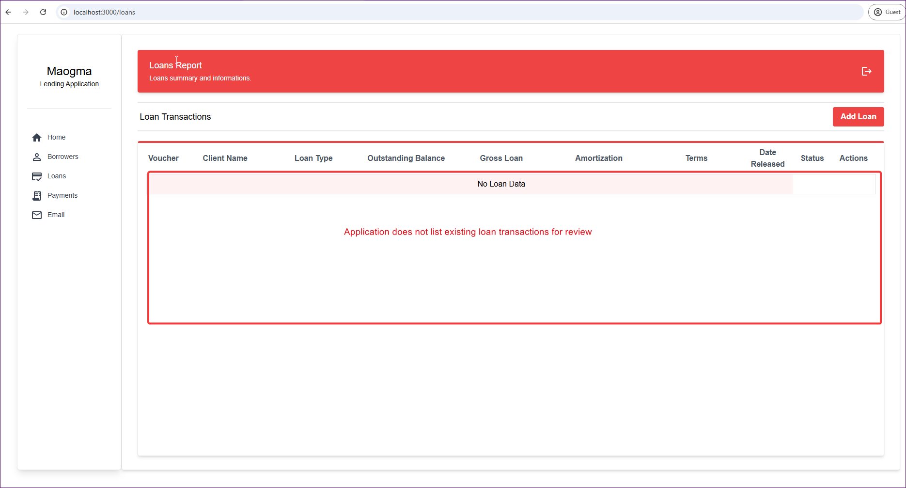

1. **Steps to reproduce**
2. Login to the application
3. Click on the loans button in the left menu
4. Application should list all existing loan transactions in the system.
5. Actions Taken by Tester
   1. Analyzed code for Root Cause (RC)
   2. RC was API query was referencing a non-existing column in DB.
   3. Corrected the query.

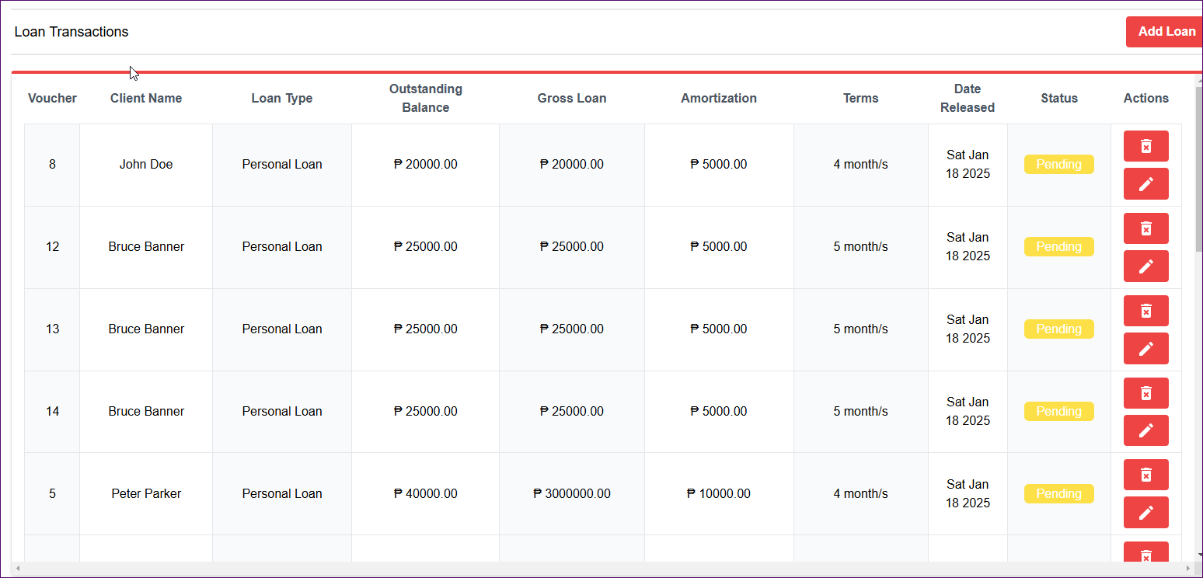

##### TC_LM_009: Application does not save new loan form data when a user clicks on the Add New Loan Button

Application does not save new loan form data when a user clicks on the Add New Loan Button

As a user, I need the ability to save new loan details when adding a loan transaction

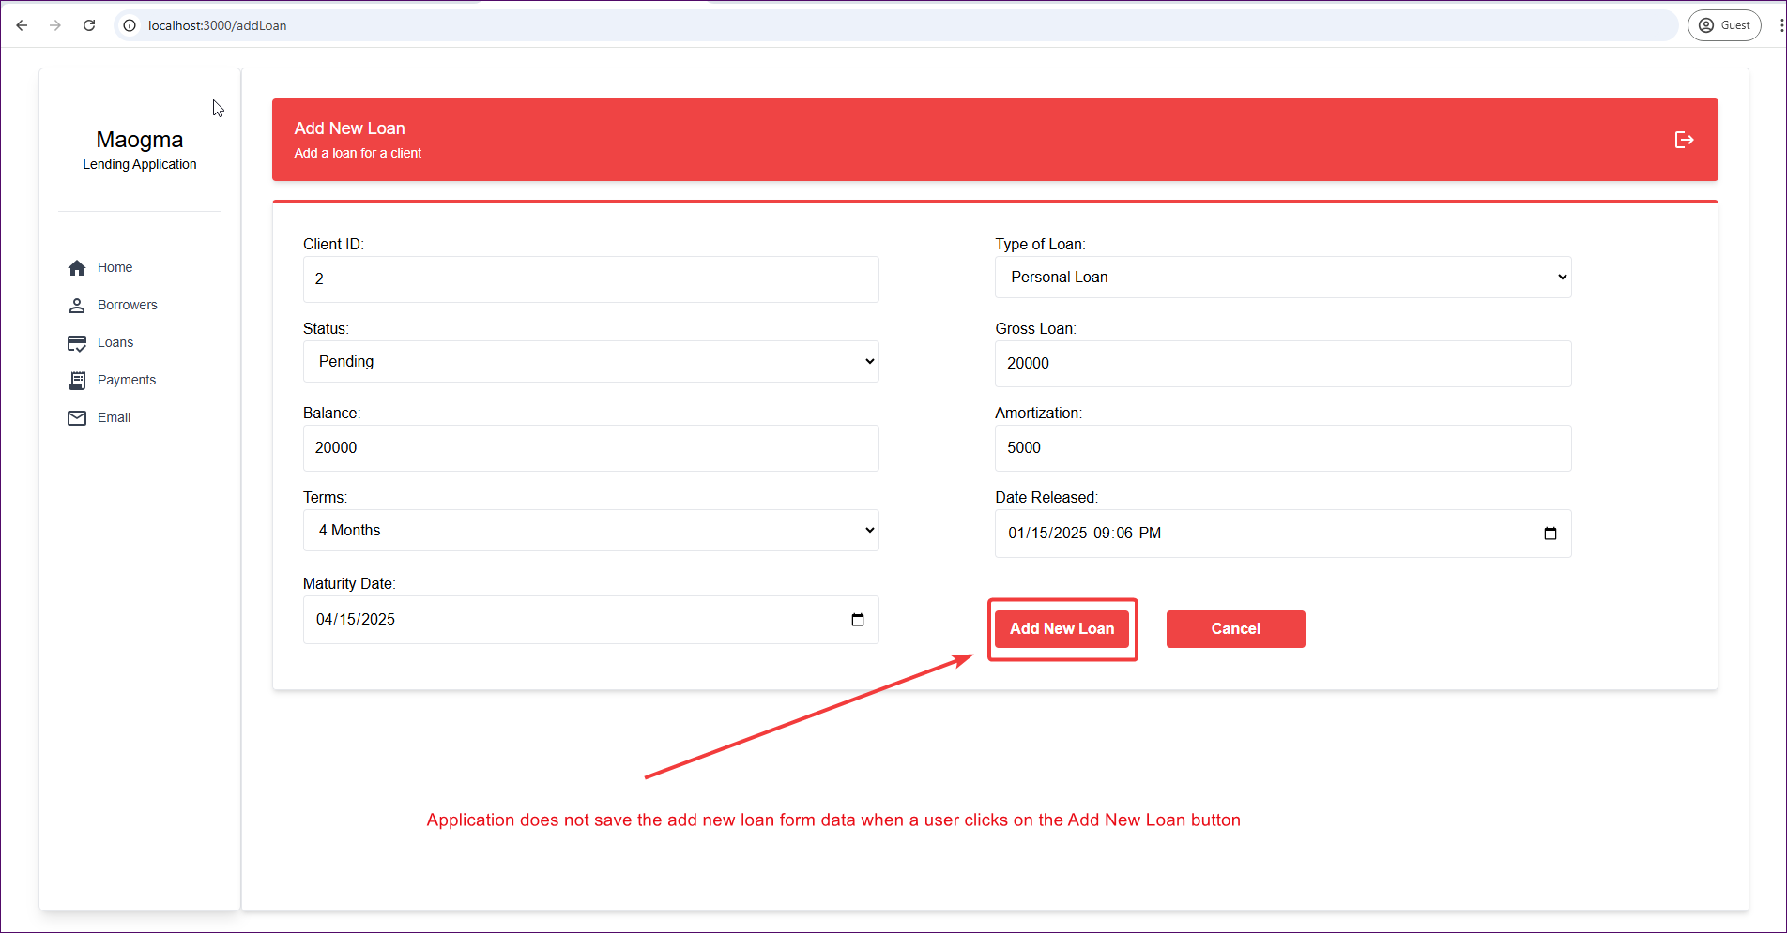

1. Steps to Reproduce
2. Login to the application
3. Click on the loans button in the side menu
4. Click on Add New Loan Button
5. Feel the New loan form with loan Details
6. Click Add New Loan Button as shown in the screenshot
7. Steps Taken By Tester.
   1. Analyzed code for Root Cause (RC)
   2. RC was API query was referencing a non-existing column in DB.
   3. Corrected the query.

### Module: Client Management - TC_CM

##### TC_CM_009: Application does not save new borrower details when a user clicks the save button as per below Image

Application does not save new borrower details when a user clicks the save button as per below Image

As a user, I need the ability to save new borrower details and add borrower to the system

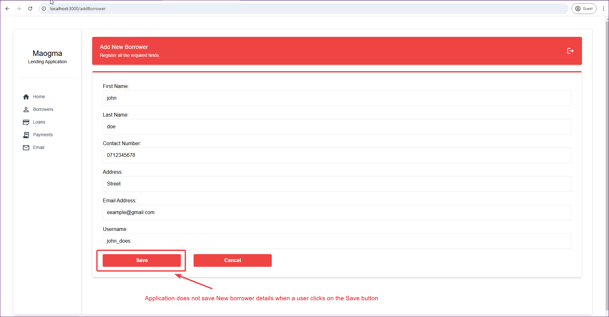

1. Steps to Reproduce
2. Login to the application
3. Click on the Borrowers button in the side menu
4. Click on Add Borrower Button
5. Feel the New borrower form with borrower details
6. Click Add New Loan Button as shown in the screenshot
7. Steps Taken By Tester.
   1. Analyzed code for Root Cause (RC)
   2. RC was API query was referencing a non-existing column in DB.
   3. Corrected the query.

##### TC_CM_017: Application does not save the borrower new loan details when a user clicks on the add new loan button

Application does not save borrower loan details when a user clicks on the Add New loan button. As a user, I need the ability to add a loan to a borrower.

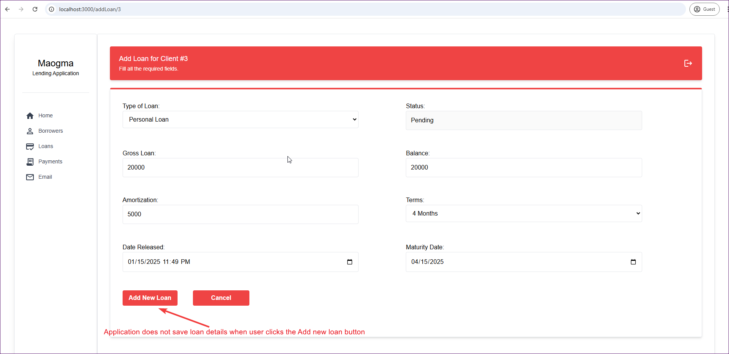

1. **Steps to Reproduce**
2. Login into the application
3. Click on the Borrowers button in the left menu
4. Click on the eye Icon for a borrower to open borrower details window
5. Click on the Add Loan button in the borrower details window
6. Feel the new loan details in the loan form
7. Click the Add New Loan button
8. **Steps Taken By Tester.**
   1. Analyzed code for Root Cause (RC)
   2. RC was API query was referencing a non-existing column in DB.
   3. Corrected the query.

### Module: Client Management - TC_PM

##### TC_PM_007: Application does not delete payments transactions from DB

As a user, I need the ability to delete payments from the system

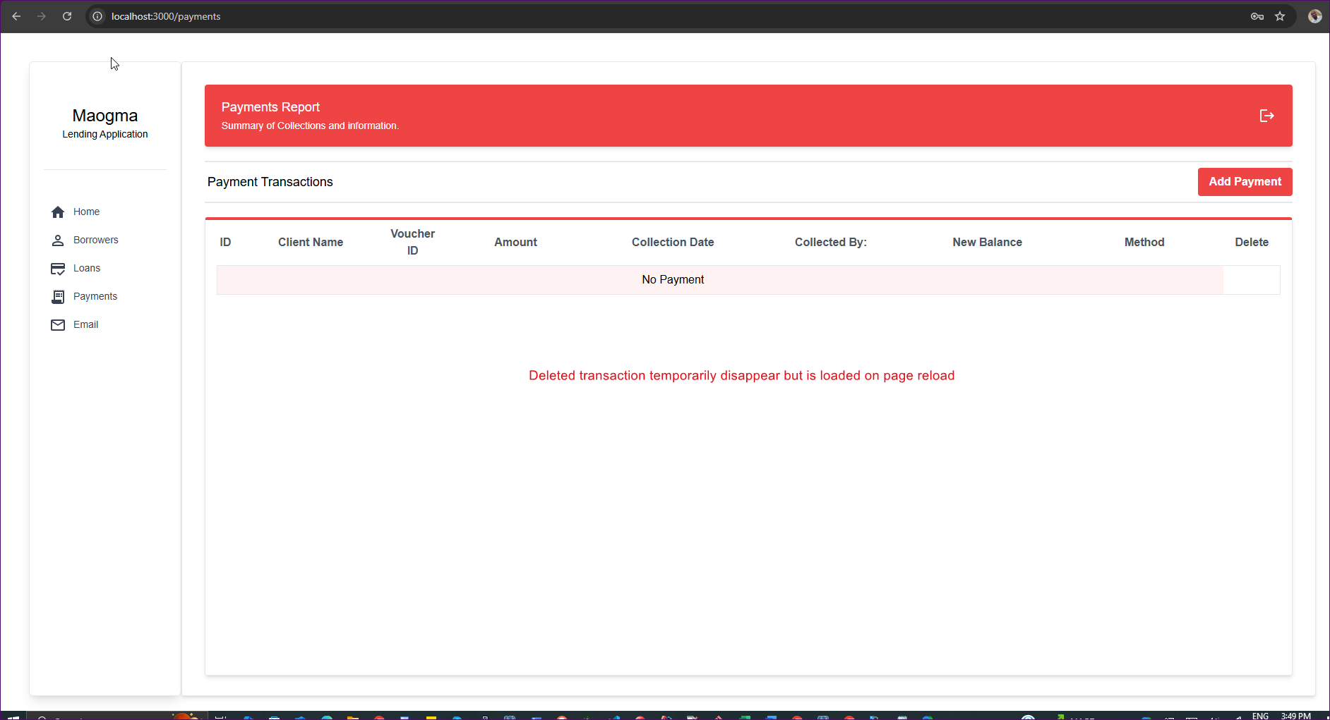

1. **Steps to Reproduce**
2. Login into the application
3. Click on the Payments button in the left menu
4. Click on the payment delete Icon button in the delete column
5. **Steps Taken By Tester.**
   1. Analyzed code for Root Cause (RC)
   2. RC was API query was referencing a non-existing column in DB.
   3. Corrected the query.

### Module: Email Notification - TC_EN

##### TC_EN_011: Application does not perform Email for validation

Application does not perform email form validation for empty fields and sends email even when the form is empty.

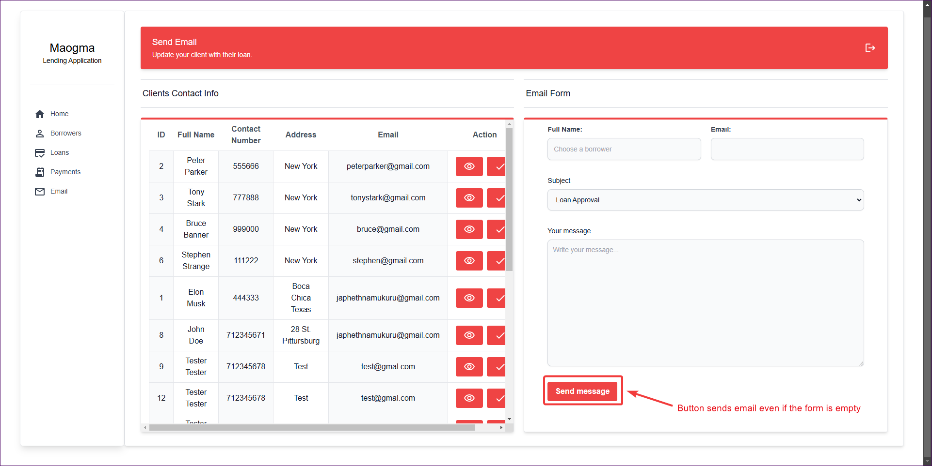

1. **Steps to Reproduce**
2. Login into the application
3. Click on the Email button in the left menu
4. Click the Send Button.
5. **Steps Taken By Tester.**
   1. Analyzed code for Root Cause (RC)
   2. Configure email from emailjs dashboard.
   3. Introduce form validation for empty fields

### Conclusion

Most defects were caused by inconsistent API queries, lack of form validation and poor token management